**Bellringer:**  Cell Membrane Labeling

AP Biology

Label the following structures: Peripheral proteins, Extracellular matrix, Glycolipid , Glycoprotein  
Channel Protein, Phospholipid, Outside of cell , Inside of cell , Cytoskeleton, Integral Protein

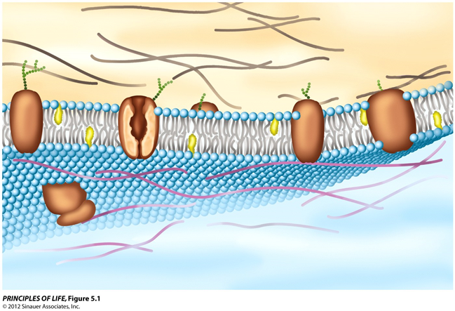

**Bellringer:**  Cell Membrane Labeling

AP Biology

Label the following structures: Peripheral proteins, Extracellular matrix, Glycolipid , Glycoprotein  
Channel Protein, Phospholipid, Outside of cell , Inside of cell , Cytoskeleton, Integral Protein

